Suggested Activities for the Week

Monday

Math

Time | Activity | Alternative | Description
20 minutes | Studyladder.ca | Start Activity Sheet 1 | If using studyladder work on “set tasks”
20 minutes | Go Fish Division! | Khan Academy | This is a new game; we played a similar one in class with multiplication. Just like regular Go Fish but instead of asking your opponent for a number you ask them the dividend.  1: choose the what number you’re practicing dividing by. ex.4  2: start to play Go Fish but if you want to know if your opponent has a 3 you will ask them if they have a 12 because 12 ÷ 4 = 3  3: another example; if you are practicing dividing by 5 and you want to know if your opponent has a 7 you will ask them if they have 35 because 35 ÷ 5 = 7  It’s complicated at the beginning but loads of fun once you get the hang of it!
20 minutes | If I had a Million Dollars …! |  | Start “shopping” check flyers, catalogues, or go online if it’s a good time. Make a shopping list of everything you would buy if you had $1 000 000; don’t go over! Make a poster (big, small, or virtual [sway]) and keep track of your spending!

Bonus: Sing! Serenade your household with a moving rendition of Les chiffres de 1 à 100. https://www.youtube.com/watch?v=GYJxoK7PKwM

Sit somewhere cozy and read for 30 minutes!

Tuesday

Language Arts

Time | Activity | Alternative | Description
20 minutes | https://www.education.com/game/floyd-danger-spelling-quest/ | Begin Activity Sheet 2
20 minutes | Writing |  | Start to plan a story.  In need of inspiration? Would what you would see in the mirror of Erised change since school has been out or would it be the same?  Remember the Writing Process:  Brainstorm Ideas  Plan  Draft  Revise  Edit Publish
20 minutes | Responding to Reading  Novel Study Choice Board (Attached) |  | Choose one of the activities on one of the boards to start working on. Next time you’ll choose a different one!

Bonus: Sing! Serenade your household with a moving rendition of Ma famille. https://www.youtube.com/watch?v=MFk9YmJv-jc

Sit somewhere cozy and read for 30 minutes!

Wednesday

Math

Time | Activity | Alternative | Description
20 minutes | Studyladder.ca | Finish Activity Sheet 1 | If using studyladder work on “set tasks”
20 minutes | Go Fish Division! | Khan Academy | This is a new game; we played a similar one in class with multiplication. Just like regular Go Fish but instead of asking your opponent for a number you ask them the dividend.  1: choose the what number you’re practicing dividing by. ex.4  2: start to play Go Fish but if you want to know if your opponent has a 3 you will ask them if they have a 12 because 12 ÷ 4 = 3  3: another example; if you are practicing dividing by 5 and you want to know if your opponent has a 7 you will ask them if they have 35 because 35 ÷ 5 = 7  It’s complicated at the beginning but loads of fun once you get the hang of it!
20 minutes | If I had a Million Dollars …! |  | Continue “shopping” check flyers, catalogues, or go online if it’s a good time. Make a shopping list of everything you would buy if you had $1 000 000; don’t go over! Make a poster (big, small, or virtual [sway]) and keep track of your spending!

Bonus: Sing! Serenade your household with a moving rendition of Les mois de l’année. https://www.youtube.com/watch?v=7_u2SigckNQ

Sit somewhere cozy and read for 30 minutes!

Thursday

Language Arts

Time | Activity | Alternative | Description
20 minutes | Continue: https://www.education.com/game/floyd-danger-spelling-quest/ | Finish Activity Sheet 2
20 minutes | Writing |  | Continue your story.  In need of inspiration? Would what you would see in the mirror of Erised change since school has been out or would it be the same?  Remember the Writing Process:  Brainstorm Ideas  Plan  Draft  Revise  Edit Publish
20 minutes | Responding to Reading  Novel Study Choice Board (Attached) |  | Choose one of the activities on one of the boards to start working on. Next time you’ll choose a different one!

Bonus: Ask everyone in your household when their birthday is.

Quand est ta fête?

Do you need help remembering the months? Sing along to … https://www.youtube.com/watch?v=7_u2SigckNQ

Sit somewhere cozy and read for 30 minutes!

Friday

Art

Egg Carton Sculptures! You can find more details at https://minimadthings.com/blogs/news/egg-carton-faces or let your creativity taker over!

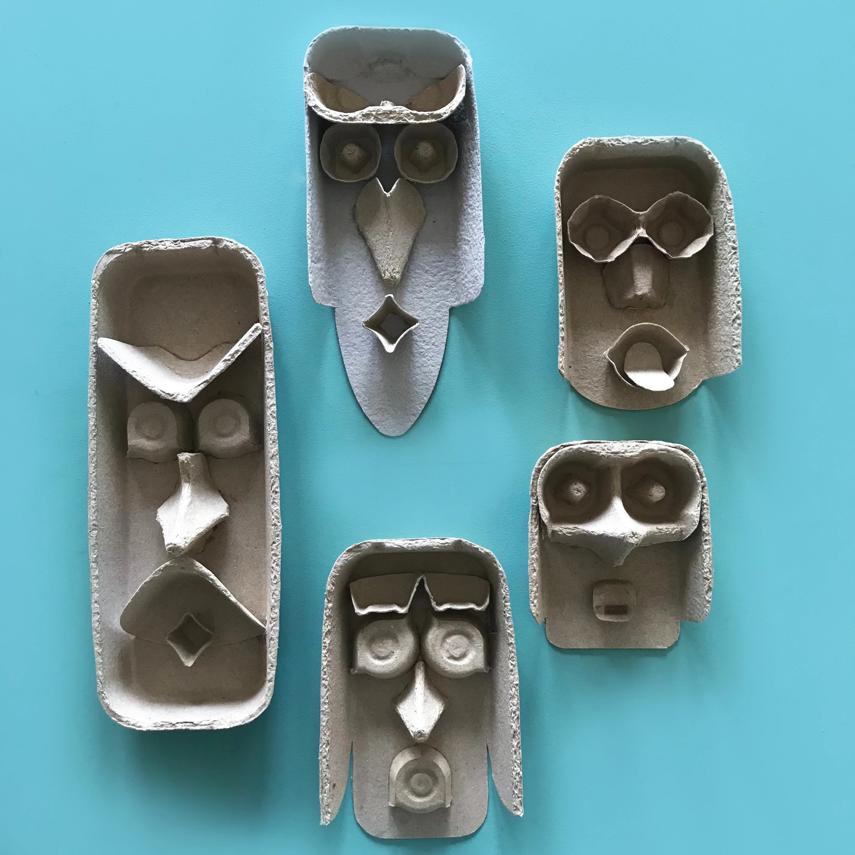

Bonus: Sing! Serenade your household with a moving rendition of Arc en ciel. https://www.youtube.com/watch?v=-4kNeFGBAcw

Sit somewhere cozy and read for 30 minutes!

